**Exercise 4: Functions**

* **Scenario 1:** Calculate the age of customers for eligibility checks.
* **Question:** Write a function *CalculateAge* that takes a customer's date of birth as input and returns their age in years.
* The CalculateAge function computes the ag and returns the result. The DECLARE block initialize a cursor to select customer details. A loop fetches each customer’s details and calculating their age by using that function. Lastly, close the cursor after doing operations.

**The OUTPUT :**

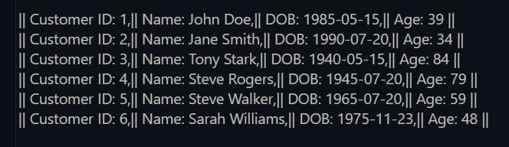

* **Scenario 2:** The bank needs to compute the monthly installment for a loan.
* **Question:** Write a function ***CalculateMonthlyInstallment*** that takes the loan amount, interest rate, and loan duration in years as input and returns the monthly installment amount.
* The *CalculateMonthlyInstallment* function calculates monthly loan *installments* based on the loan amount, annual interest rate, and loan duration in years using the EMI formula. It converts annual interest to monthly and the loan duration in years to month.
* By using a cursor it fetch loan details and and clalculate monthly installment.

**The OUTPUT :**

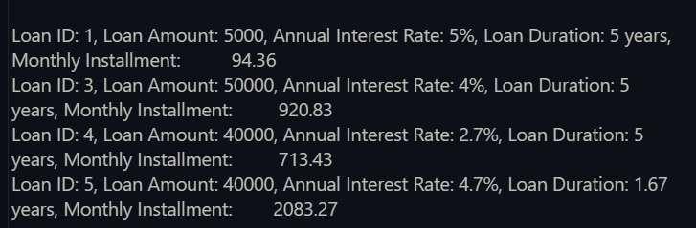

* **Scenario 3:** Check if a customer has sufficient balance before making a transaction.
* **Question:** Write a function ***HasSufficientBalance*** that takes an account ID and an amount as input and returns a Boolean indicating whether the account has at least the specified amount.
* The *HasSufficientBalance* function takes an account ID and an amount as parameters and checks if the account has a balance greater than or equal to the specified amount. It retrieves account balance. This function returns true if there is sufficient balance. If no data found then return false, this is an exception.
* In DECLARE Block it test the function.

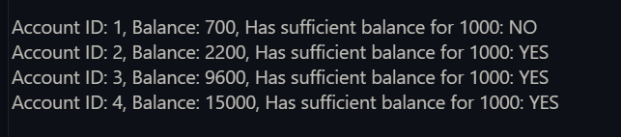**The OUTPUT:**